**Week – 7**

**React**

**Objectives**

* **Explain React events**
* **Explain about event handlers**
* **Define Synthetic event**
* **Identify React event naming convention**

**In this hands-on lab, you will learn how to:**

* **Implement Event handling concept in React applications**
* **Use this keyword**
* **Use synthetic event**

**Prerequisites**

**The following is required to complete this hands-on lab:**

* **Node.js**
* **NPM**
* **Visual Studio Code**

**Notes**

**Estimated time to complete this lab: 90 minutes.**

**Create a React Application “eventexamplesapp” to handle various events of the form elements in HTML.**

1. **Create “Increment” button to increase the value of the counter and “Decrement” button to decrease the value of the counter. The “Increase” button should invoke multiple methods.** 
   1. **To increment the value**
   2. **Say Hello followed by a static message.**

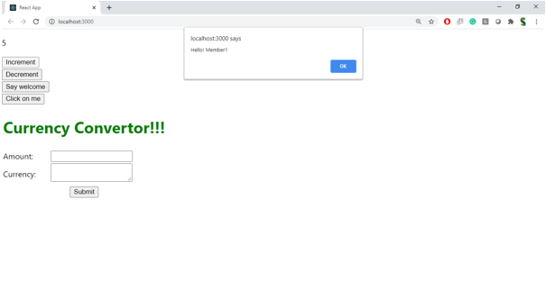

1. **Create a button “Say Welcome” which invokes the function which takes “welcome” as an argument.**

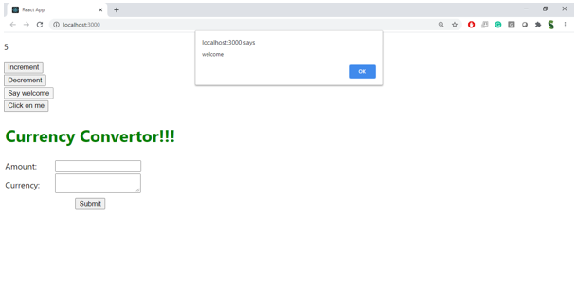

1. **Create a button which invokes synthetic event “OnPress” which display “I was clicked”**

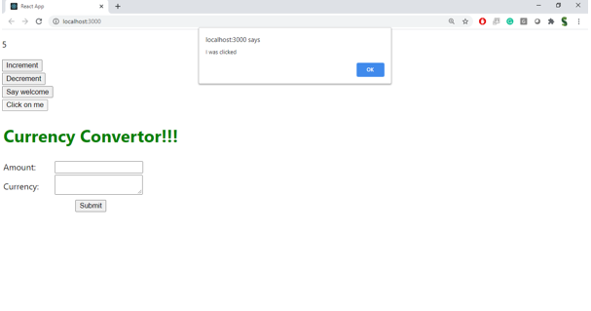

**Create a “CurrencyConvertor” component which will convert the Indian Rupees to Euro when the Convert button is clicked.**

**Handle the Click event of the button to invoke the handleSubmit event and handle the conversion of the euro to rupees.**

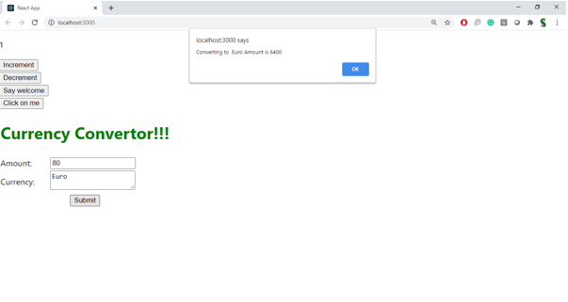

**IMPLEMENTATION :**

import React, { Component } from "react";

// Currency Converter Component

class CurrencyConverter extends Component {

constructor(props) {

super(props);

this.state = {

rupees: "",

euros: "",

};

}

handleChange = (event) => {

this.setState({ rupees: event.target.value });

};

handleSubmit = (event) => {

event.preventDefault();

let rupees = parseFloat(this.state.rupees);

if (!isNaN(rupees)) {

// Approx conversion rate

let euros = rupees * 0.011;

this.setState({ euros: euros.toFixed(2) });

}

};

render() {

return (

<div style={{ marginTop: "30px" }}>

<h2>Currency Converter</h2>

<form onSubmit={this.handleSubmit}>

<label>

Enter amount in ₹:

<input

type="number"

value={this.state.rupees}

onChange={this.handleChange}

style={{ marginLeft: "10px" }}

/>

</label>

<button type="submit" style={{ marginLeft: "10px" }}>

Convert

</button>

</form>

{this.state.euros && (

<p>

Equivalent in €: <b>{this.state.euros}</b>

</p>

)}

</div>

);

}

}

// Main App Component

class App extends Component {

constructor(props) {

super(props);

this.state = {

count: 0,

};

}

// Increment method

increment = () => {

this.setState({ count: this.state.count + 1 });

};

// Multiple method call

sayHello = () => {

alert("Hello! This is a static message.");

};

incrementAndGreet = () => {

this.increment();

this.sayHello();

};

// Decrement method

decrement = () => {

this.setState({ count: this.state.count - 1 });

};

// Passing argument

sayMessage = (msg) => {

alert(msg);

};

// Synthetic event handler

handlePress = (event) => {

alert("I was clicked");

console.log("Synthetic Event Object:", event);

};

render() {

return (

<div style={{ textAlign: "center", marginTop: "30px" }}>

<h1>React Event Handling Examples</h1>

<h2>Counter: {this.state.count}</h2>

<button onClick={this.incrementAndGreet} style={{ margin: "5px" }}>

Increment

</button>

<button onClick={this.decrement} style={{ margin: "5px" }}>

Decrement

</button>

<div style={{ marginTop: "20px" }}>

<button onClick={() => this.sayMessage("Welcome")} style={{ margin: "5px" }}>

Say Welcome

</button>

</div>

<div style={{ marginTop: "20px" }}>

<button onClick={this.handlePress} style={{ margin: "5px" }}>

OnPress (Synthetic Event)

</button>

</div>

{/* Currency Converter */}

<CurrencyConverter />

</div>

);

}

}

export default App;

**OUTPUT :**

